Step User at New & Used Car Search - carsguide  
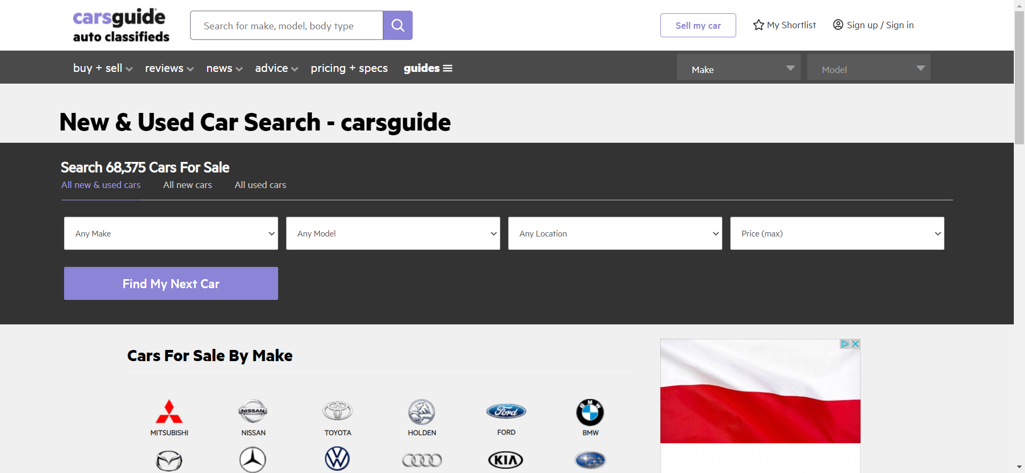  
  
Step Searched cars are  
